**Practical-1**

**Aim:** **Write a program to convert rupees to dollar. 60 rupees=1 dollar.**

class r2d {

float rs,dollar;

void convert(float rs){

dollar = rs/60;

System.out.println("Dollar is " +dollar);

}

}

class d2r {

float rs,dollar;

void convert(float dollar){

rs = dollar * 60;

System.out.println("Rs is " +rs);

}

}

class conversion {

public static void main(String args[]){

r2d r = new r2d();

d2r d = new d2r();

r.convert(120);

d.convert(2);

}

}

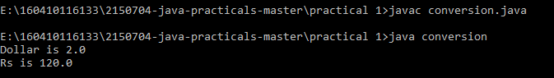

**Aim:** **Write a program that calculates percentage marks of the student if marks of 6 subjects are given.**

import java.util.*;

class inpt

{

float s1[]= new float [6];

float n,sum=0;

void inp()

{

Scanner value= new Scanner(System.in);

System.out.println("No of Subjects you want to enter marks for:");

n=value.nextFloat();

if(n!=6)

{

System.out.println("ERROR");

}

else

{

System.out.println("Enter Marks of Subjects:");

for(int i=0;i<n;i++)

{

s1[i]=value.nextFloat();

}

}

}

void marks()

{

float sum=0,per;

for(int i=0;i<6;i++)

{

sum=sum+s1[i];

}

per=sum/6;

System.out.println("Percent=" +per);

}

}

class abc

{

public static void main(String args[])

{

float a;

inpt ABC= new inpt();

ABC.inp();

ABC.marks();

}

}

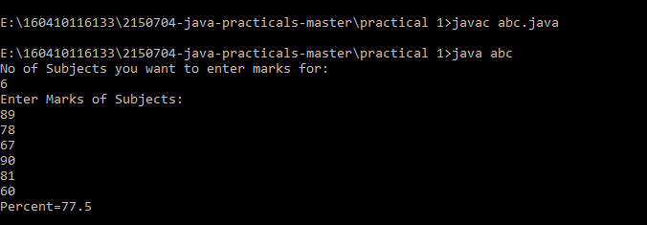

**Practical-2**

**Aim:** **Write a program to find length of string and print second half of the string**

import java.util.*;

class input{

public static void main(String args[]){

int i;

String a;

Scanner AB = new Scanner(System.in);

a = AB.nextLine();

int l = a.length();

char def[] = new char[a.length()];

System.out.println("Length is = " +l);

System.out.println("Half of string is :" +a.substring(l/2));

a.getChars(0, a.length(),def,0);

for(i=a.length()/2;i<a.length();i++){

System.out.print(" "+def[i]);

}

char x[] = a.toCharArray();

for(i=x.length/2;i<x.length;i++){

System.out.println(" "+x[i]);

}

}

}

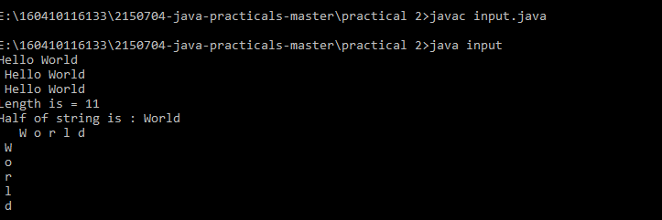

**Aim: Write a program to enter two numbers and perform mathematical operations on them.**

import java.util.*;

public class Cla

{

public static void main(String[] args)

{

int a,b;

float res;

Scanner scan=new Scanner(System.in);

System.out.print("enter the value of a");

a=scan.nextInt();

System.out.println("enter the value of b");

b=scan.nextInt();

res=a+b;

System.out.println("addition=="+res);

res=a-b;

System.out.println("subtraction=="+res);

res=a*b;

System.out.println("multiplication=="+res);

res=(float)a/(float)b;

System.out.println("division=="+res);

}

}

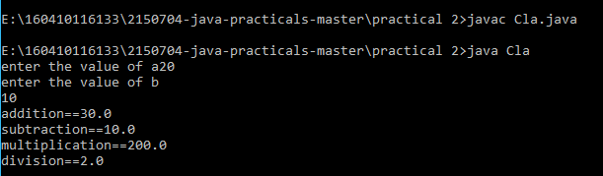

**Practical-3**

**Aim:** **Write a program to accept a line and check how many consonants and vowels are there in line**

import java.util.*;

class s1{

public static void main(String args[]){

int i;

String a;

Scanner AB = new Scanner(System.in);

a = AB.nextLine();

System.out.println(" " +a);

for(i=0;i<a.length();i++){

if(a.charAt(i)=='a' || a.charAt(i) == 'e'|| a.charAt(i) == 'i'|| a.charAt(i) == 'o'|| a.charAt(i) == 'u'|| a.charAt(i) == 'A'|| a.charAt(i) == 'E'|| a.charAt(i) == 'I'|| a.charAt(i) == 'O'|| a.charAt(i) == 'U'){

System.out.println("Vowels are " +a.charAt(i));

}

else{

System.out.println("Consonants are " +a.charAt(i));

}

}

}

}

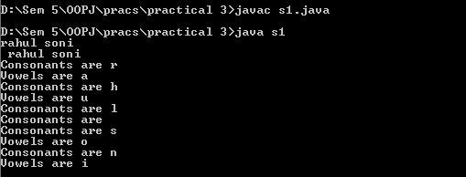

**Aim: Write a program to count the number of words that start with capital letters**

import java.util.*;

class r1{

public static void main(String args[]){

int i,word=0,space=0;

String a;

Scanner AB = new Scanner(System.in);

a = AB.nextLine();

System.out.println(" " +a);

for(i=0;i<a.length();i++){

char ch = a.charAt(i);

if(ch == 32){

space++;

}

if (Character.isUpperCase(ch)

&& (i == 0 || Character.isWhitespace(a.charAt(i - 1)))) {

word++;

}

}

System.out.println("Total capital words" +word);

System.out.println("Total spaces" +space);

}

}

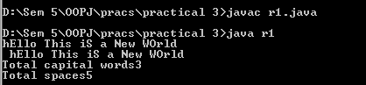

**Practical-4**

**Aim:** **Write a program to find that given number or string is palindrome or not.**

import java.util.*;

class input{

String name = "";

void set(String a){

name = a;

}

void get(){

System.out.println(" " +name);

}

}

class palindrome {

public static void main(String args[]){

String s1,s2;

int i;

input a1 = new input();

Scanner AB = new Scanner(System.in);

s1 = AB.nextLine();

a1.set(s1);

a1.get();

s2 = "";

for(i=s1.length()-1;i>=0;i--){

s2 = s2+s1.charAt(i);

}

if(s2.equalsIgnoreCase(s1)){

System.out.println("Palindrome");

}

else{

System.out.println("Not Palindrome");

}

}

}

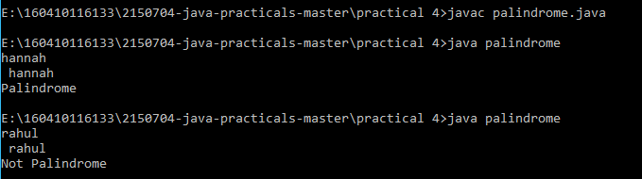

**Aim:** **Create a class which asks the user to enter a sentence, and it should display count of each vowel type in the sentence. The program should continue till user enters a word “quit”. Display the total count of each vowel for all sentences.**

import java.util.*;

class quit{

public static void main(String args[]){

String s1,s2;

int i,count=0;

Scanner AB = new Scanner(System.in);

s1 = AB.nextLine();

while(AB.hasNext()){

s2 = AB.nextLine();

if(s2.equalsIgnoreCase("quit"))

break;

s1 = s1+s2;

}

System.out.println("Ans: " +s1);

for(i=0;i<s1.length();i++){

if(s1.charAt(i)=='a' || s1.charAt(i) == 'e'|| s1.charAt(i) == 'i'|| s1.charAt(i) == 'o'|| s1.charAt(i) == 'u'|| s1.charAt(i) == 'A'|| s1.charAt(i) == 'E'|| s1.charAt(i) == 'I'|| s1.charAt(i) == 'O'|| s1.charAt(i) == 'U'){

count++;

}

}

System.out.println("Number of vowels " +count);

}

}

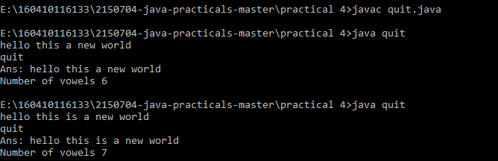

**Practical-5**

**Aim:** **Write an interactive program to print a string entered in a pyramid form. For instance, the string “stream” has to be displayed as follows:**

**S**

**S t**

**S t r**

**S t r e**

**S t r e a**

**S t r e a m**

import java.util.*;

class pattern{

public static void main(String args[]){

String s1,s2="";

int i,j,k=50;

Scanner AB = new Scanner(System.in);

s1 = AB.nextLine();

for(i=0;i<s1.length();i++){

for(j=0;j<k;j++){

System.out.print(" ");

}

k=k-1;

for(j=0;j!=i+1;j++){

System.out.print(" "+s1.charAt(j));

}

System.out.println();

}

}

}

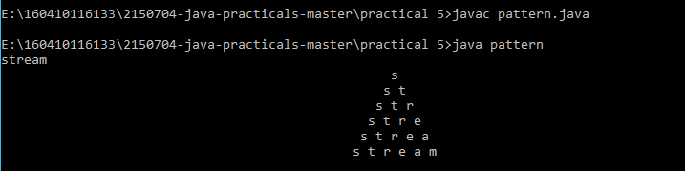

**Aim:** **Write an interactive program to print a diamond shape. For example, if user enters the number 3, the diamond will be as follows:**

**\***

**\* \***

**\* * \***

**\* \***

**\***

import java.util.*;

class pattern2{

public static void main(String args[]){

String s1,s2="";

int i,j,k=50;

Scanner AB = new Scanner(System.in);

s1 = AB.nextLine();

for(i=0;i<s1.length();i++){

for(j=0;j<k;j++){

System.out.print(" ");

}

k=k-1;

for(j=0;j!=i+1;j++){

System.out.print(" "+s1.charAt(j));

}

System.out.println();

}

k=52-s1.length();

for(i=s1.length();i!=0;i--){

for(j=0;j!=k;j++){

System.out.print(" ");

}

k=k+1;

for(j=i-1;j!=0;j--){

System.out.print(" "+s1.charAt(j));

}

System.out.println();

}

}

}

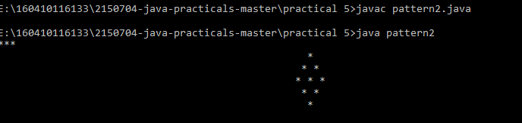

**Practical-6**

**Aim:** **Create one Abstract Class Shape that has two variables for dimensions and one Abstract method called area (). Create two subclass Rectangle and Triangle of Shape class and find the area of Rectangle and Triangle. Create appropriate Constructors for data.**

import java.util.*;

abstract class shape {

int d1,d2;

abstract void area(int d1 , int d2);

}

class triangle extends shape{

int base,height,area;

triangle(){

base = 0;

height = 0;

area = 0;

}

void set(int b, int h){

base = b;

height = h;

}

void area(int base,int height){

area = (base*height)/2;

System.out.println("Triangle Area = " +area);

}

}

class rectangle extends shape{

int length,breadth,area;

rectangle(){

length = 0;

breadth = 0;

area = 0;

}

void set(int l, int b){

length = l;

breadth = b;

}

void area(int length, int breadth){

area = (length*breadth);

System.out.println("Rectangle area = " +area);

}

}

public class geoshape{

public static void main(String args[]){

int a,b,c,d;

Scanner AB = new Scanner(System.in);

System.out.println("Enter values for triangle");

a = AB.nextInt();

b = AB.nextInt();

System.out.println("Enter values for rectangle");

c = AB.nextInt();

d = AB.nextInt();

triangle t1 = new triangle();

rectangle r1 = new rectangle();

t1.set(a,b);

t1.area(a,b);

r1.set(c,d);

r1.area(c,d);

}

}

